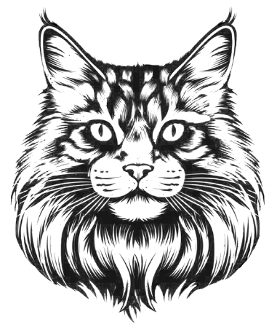
MAINE COON UNION
LITTER REGISTRATION FORM
Female Owner/s  Click or tap here to enter text. |  |  | Male owner/s The owner of the male is the same as female  Click or tap here to enter text. ☐
Address  Click or tap here to enter text. |  |  | Address  Click or tap here to enter text.
Click or tap here to enter text. | Country  Click or tap here to enter text. |  | Click or tap here to enter text. |  | Country  Click or tap here to enter text.
Cattery name for the one registering the litter  Click or tap here to enter text. |  |  | Male name  Click or tap here to enter text.
Female name  Click or tap here to enter text. |  |  | Male reg.no  Click or tap here to enter text. | Male color  Click or tap here to enter text.
Female: reg no  Click or tap here to enter text. | Color:  Click or tap here to enter text. |  | Sign Male owner/s:
Kitten’s Date of birth:  Click or tap here to enter text. | Living males  0 | Living Females  0 | Sign Female owner/s:
DECLARATION
The above particulars are true to the best of my/our knowledge and belief, and I/we clarify that each of these cats or kittens were alive on the date of this form, and that they had not previously been registered. I/We have submitted to the MCU breeding rules and by this signature state that I/We have breed the litter according to them.

NAME | EMS CODE | SEX | OWNER | ACTIVE FOR BREEDING
Click or tap here to enter text. | Click or tap here to enter text. | F/M | Click or tap here to enter text. | Yes/No
Click or tap here to enter text. | Click or tap here to enter text. | F/M | Click or tap here to enter text. | Yes/No
Click or tap here to enter text. | Click or tap here to enter text. | F/M | Click or tap here to enter text. | Yes/No
Click or tap here to enter text. | Click or tap here to enter text. | F/M | Click or tap here to enter text. | Yes/No
Click or tap here to enter text. | Click or tap here to enter text. | F/M | Click or tap here to enter text. | Yes/No
Click or tap here to enter text. | Click or tap here to enter text. | F/M | Click or tap here to enter text. | Yes/No
Click or tap here to enter text. | Click or tap here to enter text. | F/M | Click or tap here to enter text. | Yes/No
Click or tap here to enter text. | Click or tap here to enter text. | F/M | Click or tap here to enter text. | Yes/No
Click or tap here to enter text. | Click or tap here to enter text. | F/M | Click or tap here to enter text. | Yes/No

I want to receive my pedigrees by: ☐ Mail ☐ E-mail

- Owners: If the Female or Male have two owners, both parts full name must be written, and both must sign.
- The owner who is registering the litter enters address.
- Names of Parents: Parents full names prefix+name must be written.
- Reg.no is the registration number of the parent.
- For the kittens to be registered with a pedigree full information must be filled in.
- For white kittens: Eye color must be stated in the EMS code.
- ACTIVE: Yes = means the new owner has breeding rights // NO = means the kitten can’t be used for breeding in MCU.
- We can’t guarantee that the cat will not be used for breeding in other associations. But MCU will only register kittens after a cat(registered in MCU) who is stated as Active for Breeding. If an application comes in with a parent that is Not Active for Breeding, the Breeder of that cat will be contacted, and has to sign the form.
- In the options for how to receive the pedigrees, both boxes can be checked. If only one option is checked, it will only be received in the chosen form.
- The form shall be sent to: REGISTRYMCU@GMAIL.COM
- It takes from 1-3 weeks to receive the pedigrees.

If you have any questions that is not stated in this document, contact our pedigree recorder’s: REGISTRYMCU@GMAIL.COM

